

**Translational Pharmacology Group**

Diseases of the Developing World

*Tres Cantos, Spain*

**Study Report**

# Study Title

Oral therapeutic efficacy of PF-06342505, against *Plasmodium falciparum* 3D7 in a murine model of malaria

# TPG Study Number

1607_TPG_071

# GSK Therapeutic Efficacy Experiment ID

120713_TE_0514 and 120914_TE_0523

# C.E.E.A. Approved Protocol

Protocol Nº 29 and 31, 01/02/11

# Report Author

Belén Jiménez

Principal Scientist, Therapeutic Efficacy, Malaria group

**Signature: Date:**

# Reviewed and Authorized

Iñigo Angulo

Manager, Therapeutic Efficacy

**Signature: Date:**

# Issue Date

17.10.2012

# Test Facilities

GSK, Diseases of the Developing World, Malaria Support Group, Calle Severo Ochoa 2, 28760-Tres Cantos, Madrid, Spain.

# Personnel in Charge of the Study

**Therapeutic efficacy**

Experiment Conducted by: Belén Jiménez-Díaz, *Principal Scientist*

Study Supervised by: Iñigo Angulo-Barturen, *Chief Scientist*

Experiment performed by: Sara Viera, *Scientist*

Helena Garuti, *Associate Scientist*

Noemí Magán, *Associate Scientist*

Lorena Cortés, *Associate Scientist*

Vanessa Gómez, *Associate Scientist*

# Location of Raw Data, Original Protocols, and Experimental Details

The original report, raw data, protocols, and experimental details pertaining to this study will be held in the GSK Archive and cross-referenced.

Route to experiment:

\\Tcadsntp004.corpnet2.com\esp_tca_ph_area-id-therapeutic_efficacy\Malaria\Experiments_underway\Ongoing\2012_Experiments\120713_TE_0514 and 120914_TE_0523

The decimal point is a dot throughout the work document.

The decimal point is a comma in the excel worksheet identified as “Experimental data”.

# Summary

The goal of this study is to measure the therapeutic efficacy of PF-06342505 against *Plasmodium* *falciparum* Pf3D70087/N9. Efficacy is assessed by administering one oral dose (2.5, 5, 10, 25, 50, 80 and 100 mg/Kg) of PF-06342505 per day for four consecutive days and measuring its effect on blood parasitemia by flow cytometry*.* The parameters of efficacy are calculated at day 7 after infection. The pharmacokinetic parameters upon oral administration of PF-06342505 are analyzed by measuring compound levels in serial blood samples obtained during the 23 h period after first dose in all mice of the efficacy experiment. The area under the curve (AUC0-23h) of levels of compound obtained for each mice are used to determine the potency of PF-06342505.

In the aforementioned experimental conditions, PF-06342505 is efficacious against *Plasmodium falciparum*. The dose, in mg/Kg that reduced parasitemia at day 7 after infection by 90 % with respect to vehicle-treated mice is ED90= 6.3 mg/Kg for PF-06342505.

The estimated exposure necessary to reduce *Plasmodium falciparum* parasitemia in peripheral blood at day 7 after infection by 90% with respect to vehicle-treated mice is AUCED90= 0.58 µg·h·ml-1·day-1 for PF-06342505.

# Therapeutic Efficacy Protocol

|  |  |
| --- | --- |
| ***Support Group Study No.*** | 1607_TPG_071 |
| ***Therapeutic efficacy study.*** | 120713_TE_0514 and 120914_TE_0523 |
| ***Applicable protocols*** | AP12918v1: In vivo assay  AP12968v1: Flow cytometry method  Protocols 120713_TE_0514 and 120914_TE_0523: Experimental details.  CEEA Protocols Nº 029 and Nº 031: Comité Etico de Experimentación Animal. |
| ***Risk assessment*** | ***P. falciparum***  Biosafety level 3  Risk of accidental inoculation with a human pathogen during experiments  Available effective treatment under medical supervision.  PNT: POMAP-17  Only staff with accredited experience participated in the experiment *in vivo*. |
| ***Assay*** | 4-day test (as described in PLoS One 2008; 3:e2252) |
| ***Nº mice/experimental group*** | 1 group with 7 mice having a range of exposure and 4 mice in vehicle group (studies: 120713_TE_0514 and 120914_TE_0523). |
| ***Mouse strain*** | NOD-*scid IL-2Rγnull*(NSG) ; (Charles River, France) |
| ***Mice age / weight*** | 21-23 g |
| ***Housing conditions***  ***Parasite*** | air-conditioned, 15 air changes per hour; 22 ± 3 ºC; 40 - 70% relative humidity; 12 h light/dark period; accomodation in racks with ventilated cages in groups of up to five (NSG) with autoclaved dust free corncob bedding (Panlab); fed with γ-irradiated pellet and ultra-filtered water *ad libitum*.  *Plasmodium* *falciparum* Pf3D70087/N9, generated in GlaxoSmithkline Tres Cantos (Spain). (PLoS One 2008; 3:e2252) |
| ***Route of infection*** | Intravenous |
| ***Infective dose*** | *P. falciparum*: 20×106 infected erythrocytes on Day 0 |
| ***Products*** | **Chloroquine** (Quality control of the assay): (CCI 5360A, batch M179/24/3)  PF-06342505 |
| ***Vehicles*** | Saline solution (vehicle for Chloroquine) |
|  | 1.5% Hydroxypropyl methylcellulose and 0.15% Sodium docedyl sulfate (vehicle for PF-06342505). |
| ***Route of administration*** | p.o. |
| ***Volume of administration (ml/Kg)*** | 20 mL/Kg |
| ***Target doses (mg/Kg)*** | **Chloroquine** (iQC): 2.5, 5 and 10 mg/Kg  **PF-06342505:** 2.5, 5, 10, 25, 50, 80 and 100 mg/Kg. |
| ***Nº doses/mouse*** | 4 |
| ***Administration schedule*** | u.i.d (once a day) starting on day 3 after infection |
| ***Quality control product preparation*** | Yes |
|  |  |
| ***Measurement of parasitemia*** | Flow cytometry (as described in Cytometry A 2009. 75A:225) |
| ***Sampling parasitemia*** | 2 µL: Days 3, 4, 5, 6 and 7after infection. |
| ***Nº of events counted*** | 106(*P. falciparum*): |
| ***Limit of detection (%)*** | 0.01% (*P. falciparum)* |
| ***Data analysis***  ***Linked studies*** | Non linear fitting to logistic equation of log10 (% parasitemia at day 7 after infection).  Parameters of efficacy:  Effective dose 90 % (ED90), defined as the dose in mg/Kg that reduce parasitemia at day 7 after infection by 90 % with respect to vehicle-treated mice  AUCED90, defined as the estimated daily exposure that reduces parasitemia from peripheral blood at day 7 after infection by 90% with respect to vehicle-treated mice.  SuG_07162012_1, SuG_07162012_2, SuG_09172012_3 and SuG_09172012_2: Compound levels  QC2012_629 and QC2012_724: Quality control |

# Deviations from Protocols

The experiments described in this report are deemed valid.

# Experiment description

The therapeutic efficacy of PF-06342505, against *P. falciparum* 3D7 is studied using a ‘4-day test’. Briefly, NODscidIL2Rγnull mice engrafted with human erythrocytes are infected with 20x106 *P. falciparum*-infected erythrocytes. Infections are performed by intravenous inoculation. All mice are randomly assigned to their corresponding treatment. The treatment starts at day 3 and finishes at day 6 after infection.

In a first observational experiment (120713_TE_0514) dose levels of 80 and 100 mg/Kg of PF-06342505 are tested. A second experiment (120914_TE_0523) is performed to study the dose response of treatment with PF-06342505. In this second experiment dose levels tested are 2.5, 5, 10, 25 and 50 mg/Kg. In all cases, the parasitemia is assessed in samples from peripheral blood obtained at days 3, 4, 5, 6, and 7 after infection. Peripheral blood samples (25 µl in 25 µl of 0.1% saponine) are taken to measure levels of compound at different times: 0.08, 0.25, 0.5, 1, 3, 6, 8 and 23 hours of PF-06342505 in the first experiment, and 0.25, 0.5, 1, 2, 4, 6, 8 and 23 hours, after the first administration of PF-06342505 in the second experiment. The lysed samples are immediately frozen in dry ice and they are stored at -80ºC until analysis. Vehicle-treated mice suffer the same blood-sampling regimen. An estimation of the AUC over the first 23h after the first administration is obtained for each mouse treated with PF-06342505.

A qualitative analysis of the effect of treatment on *P. falciparum* Pf3D70087/N9 is assessed by microscopy and flow cytometry. Fresh samples of peripheral blood from *P. falciparum*- infected mice are stained with TER-119-Phycoerythrine (marker of murine erythrocytes) and SYTO-16 (nucleic acid dye) and then acquired by flow cytometer (FACSCalibur, BD). Microscopy analysis is performed with Giemsa-stained blood smears from samples taken at days 5 and 7 (48 and 96 h after starting treatment, respectively).

# Results

## *Pharmacokinetic analysis*

The pharmacokinetic parameters of PF-06342505, upon oral administration are analyzed by measuring compound levels in serial blood samples obtained during the 23 h period after first dose in all mice of the efficacy experiment. The area under the curve (AUC0-23h) of PF-06342505 in blood of each individual mice of the efficacy experiment is used to estimate the exposure necessary to inhibit parasitemia at day 7 after infection by 90% with respect to vehicle-treated mice (*Table 1*).

## *Parameters of efficacy*

Results obtained in two independent experiments (120713_TE_0514 and 120914_TE_0523) are joined and used to assess the therapeutic efficacy of PF-06342505 against *P. falciparum (Table 1).*

The therapeutic efficacy of PF-06342505 against *P. falciparum* 3D7in a ‘4-day test’is shown in *Figure 1.*

Non-linear fitting to sigmoid dose-response curve of log10 of % parasitemia at day 7 after infection is used for the calculation of ED90 ofPF-06342505 against *P. falciparum in vivo*. The dose that reduces parasitemia by 90 % is ED90= 6.3 mg/Kg for PF-06342505 (*Figure 2 and Table 2*).

Assuming that compound accumulation does not have an important effect (*Figure 3*), the estimated exposure of PF-06342505 necessary to reduce parasitemia at day 7 after infection by 90% with respect to vehicle-treated mice is AUCED90= 0.58 µg·h·ml-1·day-1 for PF-06342505 (Figure 4 and *Table 2*).

## *Effect of treatment on parasites*

## *Pf3*D70087/N9-infected mice treated with vehicle harbour healthy rings, trophozoites and mature schizonts. However, the effect of treatment with with PF-06342505 leads to a population of low DNA staining by flow cytometry that corresponds to pyknotic parasites by microscopy (*Figure 5).*

## Quality control

*Product preparation quality control*

All the doses are checked to determine the quality of formulation. The experimental doses that showed a deviation > 10% with respect to target doses are corrected according to the quality control and the parameters of efficacy are estimated using the corrected doses.

*Biological quality control*

The *in vivo* assay against *P. falciparum* includes Chloroquine as quality control. The ED50 calculated for Chloroquine are 5 mg/Kg (120713_TE_0514) and 4.3 mg/Kg (120914_TE_0523). These values are within the interval ED50 mean ± 2 standard deviations of 58 experiments (1.8-5 mg/Kg) for Chloroquine. The vehicle-treated groups show an appropriate growth.

Therefore, the *in vivo* assays are deemed valid.

# Conclusion

In the aforementioned experimental conditions, PF-06342505 are efficacious against *P. falciparum* *in vivo*.

The parasite clearance curves for PF-06342505 in the PfalcHuMouse correspond to **fast acting compounds** (at least as fast as Chloroquine and Piperaquine, respectively).

Both PF-06342505 rapidly kill *P. falciparum in vivo* (pyknotic cells detected by flow cytometry and microscopy in peripheral blood after two administrations of the drugs).

The **potency** of PF-06342505 in the PfalcHuMouse is **comparable to antimalarial drugs on the market** (AUCED90 = 0.58 µg·h·ml-1.day-1 for PF-06342505).

## **Figure 1. *In vivo* therapeutic efficacy of PF-06342505.** Parasitemia in peripheral blood of mice infected with *P. falciparum* Pf3D70087/N9. Data shown correspond to individual parasitemia for mice treated with PF-06342505 and mean parasitemia ± SEM of n=4 mice treated with vehicle.

In brackets dose corrected according the quality control.



## **Figure 2. Dose-response relationship for PF-06342505**. Data are presented as log10 [percentage of parasitemia at day 7 after infection] versus the dose in mg/kg of individual parasitemias of mice from study 120713_TE_0514 and 120914_TE_0523.

Parasitemias lower than the limit of detection of flow cytometry (0.01%) are computed and plotted as 0.01% for dose-response curve fitting.



## **Figure 3. Whole blood levels of PF-06342505 after the first dose of treatment**. Data are individual profiles of PF-06342505 blood concentration versus time (0-23 hours) from experiments 120713_TE_0514 and 120914_TE_0523.



## **Figure 4. Estimation of exposure at ED90**. Data are presented as the log10 [percentage of parasitemia at day 7 after infection] of individual mice treated with PF-06342505 versus the corresponding individual AUC0-23h after the first oral administration.

Parasitemias lower than the limit of detection of flow cytometry (0.01%) are computed and plotted as 0.01% for dose-response curve fitting.



## Figure 5. The effect of **PF-06342505** treatment on *P. falciparum* *Pf*3D70087/N9 *in vivo*. A) Peripheral blood smears stained with Giemsa. B) Flow cytometry dot plots from samples of peripheral blood stained with TER-119-Phycoerythrine and SYTO-16. Dots inside the polygonal region represent *P. falciparum*-infected human erythrocytes.

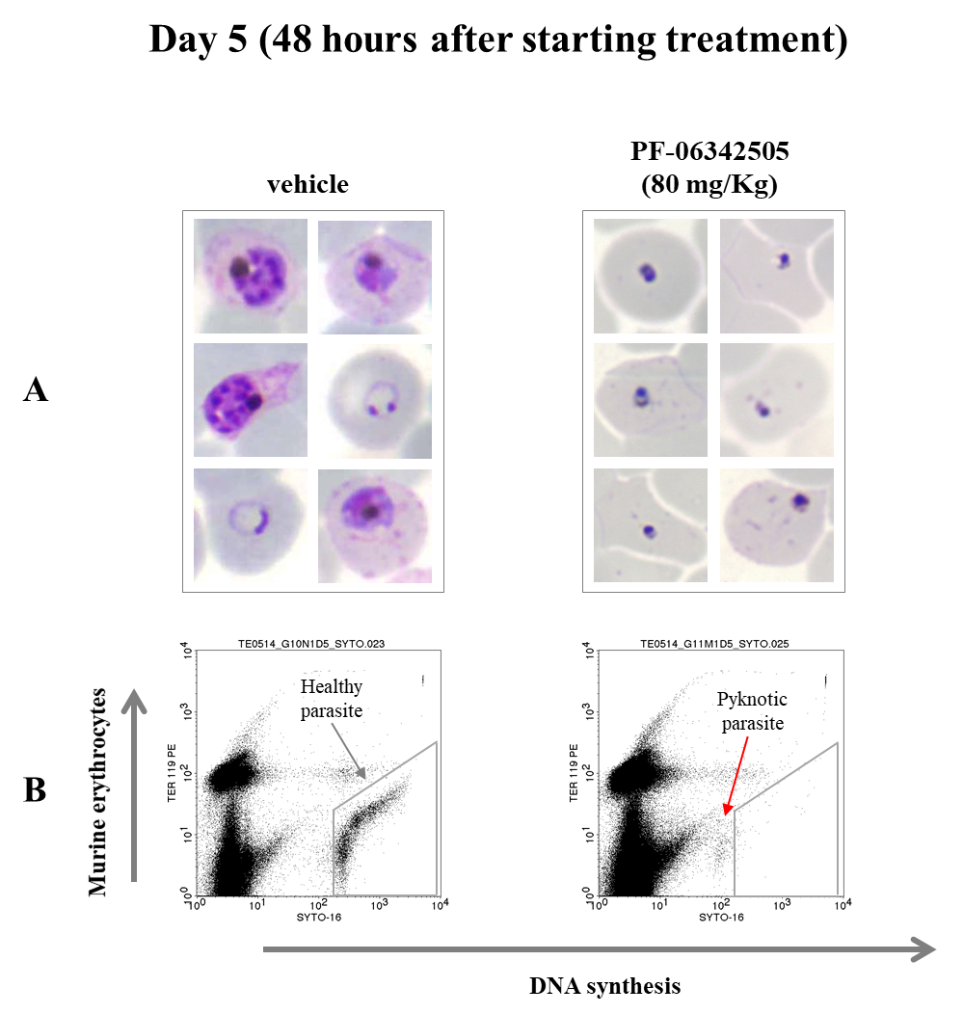

## Table 1. Summary efficacy data. The table gathers data from the experiments 120713_TE_0514 and 120914_TE_0523.

|  |  |  |  |  |  |
| --- | --- | --- | --- | --- | --- |
| **Parasite** | **Compound** | **Target Dose (mg/Kg)** | **Mouse** | **% Parasitemia at day 7 after infection** | **AUC(0-23h)**  **(µg·h·ml-1)** |
| *P. falciparum* | Vehicle | 0 | 1 | 4.87 | 0 |
| *P. falciparum* | Vehicle | 0 | 2 | 2.16 | 0 |
| *P. falciparum* | Vehicle | 0 | 3 | 4.39 | 0 |
| *P. falciparum* | Vehicle | 0 | 4 | 5.06 | 0 |
| *P. falciparum* | PF-06342505 | 2.5 (2.78) | 1 | 2.69 | 0.183 |
| *P. falciparum* | PF-06342505 | 5 (6.9) | 2 | 0.18 | 0.663 |
| *P. falciparum* | PF-06342505 | 10 (13) | 3 | < 0.01 | 1.27 |
| *P. falciparum* | PF-06342505 | 25 | 4 | < 0.01 | 2.96 |
| *P. falciparum* | PF-06342505 | 50 (56.6) | 5 | < 0.01 | 11.05 |
| *P. falciparum* | PF-06342505 | 80 | 6 | < 0.01 | 11.17 |
| *P. falciparum* | PF-06342505 | 100 | 7 | < 0.01 | 15.34 |

Parasitemia detection limit: 0.01%

In brackets: Dose corrected according to quality control of formulation.

## Table 2. Parameters of efficacy for PF-06342505 in a ‘4-day-test’ against *P falciparum* *Pf*3D70087/N9.

|  |  |  |  |  |  |  |
| --- | --- | --- | --- | --- | --- | --- |
| **Compound** | **Method of estimation** | **Goodness of fit** | **Parameter** | **Mean** | **Interval of confidence of the mean at 95% (IC95)** | **Unit of parameter** |
| PF-06342505 | log fit | 0.99 | ED90 | 6.3 | 5.9-6.8 | mg/kg |
| PF-06342505 | log fit | 0,99 | AUCED90 | 0.58 | 0.52-0.64 | µg·h·ml-1·day-1 |

## Table 3. Comparison with standard antimalarial drugs tested in the PfalcHuMouse model

|  |  |  |
| --- | --- | --- |
| **Compound** | **ED90 (mg/Kg)** | **AUCED90 (µg·h·ml-1·day-1)** |
| Atovaquone | 0.05 | 0.38 |
| Pyrimethamine | 0.9 | 1.3 |
| Chloroquine | 6 | 1 |
| Artesunate | 10 | ND |
| Lumefantrine | 12 | 3.5 |
| **PF-06342505** | **6.3** | **0.58** |
|  |  |  |

**Laboratory Practice and Animal Management Observed by**

**The Malaria Support Group**

All GlaxoSmithKline-Tres Cantos staff involved in animal research are trained to standards which are approved by recognised professional bodies and which adhere to national guidelines. Animals are transported, housed and cared for by dedicated staff. All due measures are taken to prevent or minimise pain and distress during and after experimental procedures. The Company supervises all staff appropriately and provides suitable facilities so that staff can carry out their duties responsibly and humanely. Qualified veterinarians are available at all times for advice and help in the care of animals and in the conduct of the research. In this study, all involved scientific staff followed GlaxoSmithKline’s ethical code of practice for the care and use of experimentation animals.

GlaxoSmithKline-Tres Cantos animal facilities and R&D programmes comply with all national and European Union laws, guidelines and codes of conduct for animal care and research use. In addition, GlaxoSmithKline-Tres Cantos animal facilities possess an independent accreditation of animal care by the [**Association for Assessment and Accreditation of Laboratory Animal Care**](http://www.aaalac.org/) **International**(AAALAC). AAALAC certifies that GlaxoSmithKline-Tres Cantos follows the highest standards in management programs that permit animals to grow, mature, reproduce, and maintain good health; provide for their well-being; and minimize variations that can affect research results.

The rodents used to conduct this study were obtained from internationally respected animal suppliers, namely Charles River Labs and Harlan. The animals have been bred specifically for research and were certified to be specific pathogen-free.

In order to ensure animal well-being, as well as experimental reproducibility, GlaxoSmithKline-Tres Cantos periodically and accurately monitors the physical microenvironment and macroenvironment parameters of its animal facilities. These parameters include (but are not limited to) **housing** and **space recommendations**, **temperature**, **humidity**, **ventilation** and **air pressure**, **sterilization by hydrogen peroxide vapor**, **illumination pattern**, **noise**, **food**, **water**, **bedding**, **sanitation**, **waste** **disposal**, and **pest** **control**.

During the conduction of the present Study no abnormal measurements of the aforementioned environmental parameters occurred which could affect the reliability of the data obtained.